
GR CLASS CLASSIFIED FOR STANDARD (GR CLASS)

Approval of Technical Requirements for the Acceptance of an in-water survey in lieu of dry-docking survey for ships

Name of ship | Distinctive number Of letters | Port of Registry | Gross Tonnage

Intended date of next in-water survey Intended date of next dry-docking
Note: - The survey for the approval of the following technical requirements is to be carried out while the ship is in drydock.
- This Form applies to all seagoing ships with the exception of passenger vessels.

Code Number | N | not surveyed | Y | Surveyed and found in order
 | N/A | Not applicable

Surveyed the following items and found or dealt with as indicated:

Survey items:
- The condition of the coating of the underwater part of the vessel’s hull is such that no corrosion damages affecting vessel’s integrity are to be expected to occur before the next dry-docking
- All anodes are settled for a durability till next dry-docking
- All sea inlets and discharge valves (including those of special equipment, if any) were opened up and overhauled

Rudder bearing clearances:
Rudder type:
(semi balanced or balanced rudder with heel, spade rudder / semi spade rudder / rudder supported by sole piece)

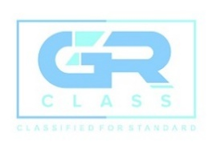
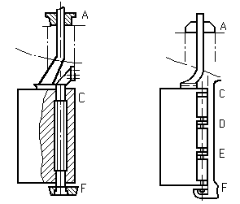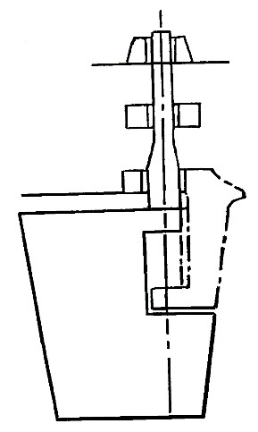
A
B
C
D

GR CLASS – CLASSIFIED FOR STANDARD (GR CLASS)
E-mail: info@grclass.com Web: www.grclass.com

Form IW-01 Approved by: GM Page 1 of 4

Clearances in rudder Bearing (mm) |  | Neck Bearing | Upper Pintle | Lower Pintle | Bottom Pintle
Fore - Aft
Port – Stbd
Bearing Material | Bush
 | Liner

Stern tube bearing clearances:

Tail Shaft type:

(Tapered Shaft, Flanged Shaft)
Type of Shaft End: (Keyed, Keyless, Flanged) Type of Bearing & Material:
(Water or Oil Lubrication, Rubber, Lignum Vitae) Tightness test of the sealing was examined:
Periodical oil analysis certificates were performed and checked: Oil consumption and shaft bearing’s temperature records were
checked:

Date of next survey of propeller shaft:
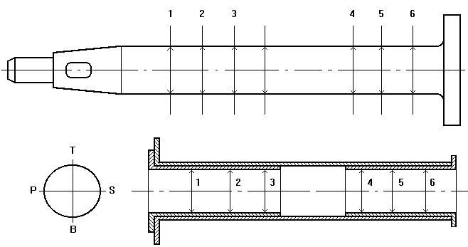

Initial Record of Clearances by feeler gauge
INNER BEARING | T-B
 | P-S
OUTER BEARING | T-B

GR CLASS – CLASSIFIED FOR STANDARD (GR CLASS)
E-mail: info@grclass.com Web: www.grclass.com

Form IW-01 Approved by: GM Page 2 of 4

 | P-S
END FACE GAP OF FLANGE | T-B
 | P-S

Tailshaft is a little higher/lower mm
Right/Left of Center mm

Position |  | 1 | 2 | 3 | 4 | 5 | 6
TAIL SHAFT | T-B
 | P-S
BUSH | T-B
 | P-S
CLEARANCE | T-B
 | P-S
Previous Clearances

Propeller:

Propeller type: (variable pitch/fixed pitch propeller)

Propeller fitting and nut securing were examined
BLADE1
BLADE3
BLADE4
BLADE2

Blades* | 1 | 2 | 3 | 4
Good
Regular
Poor
*Check for deformation, pitting, cracks, thickness of blades, fastenings and tightness of hub and blade sealings (if applicable)
 GR CLASS – CLASSIFIED FOR STANDARD (GR CLASS)
E-mail: info@grclass.com Web: www.grclass.com
Form IW-01 Approved by: GM Page 3 of 4

- Propeller shaft(s) and stern tube are protected against sea water influence
- Propeller shaft(s) and stern tube are fitted with lubricate oil bearing and sealing
- The condition of any special means of propulsion and/or maneuvering equipment is such That no damages are to be expected to occur before the next dry-docking

- Remarks:

- The vessel’s condition will allow and in-water survey in lieu of a survey requiring dry-docking in a period of five years, notwithstanding unforeseen damages or accidents.
The final approval is subject to GR CLASS-Head Office

Place and date:

Surveyor of
GR CLASS REPRESENTATIVE



GR CLASS – CLASSIFIED FOR STANDARD (GR CLASS)
E-mail: info@grclass.com Web: www.grclass.com

Form IW-01 Approved by: GM Page 4 of 4

